Order/Invoice For CAPA Exhibition Standards Medals

 | The Canadian Association For Photographic Art  L’Association canadienne d’art photographique  “Connecting Canadian Photographers”

Exhibition Standards Medals – Invoice

Invoice Date: Invoice #2022 -

Name of Club/Organization:
Contact Person:
Telephone:
Email:

Date of Order: Date Required:

Medal/Ribbon | Cost | Quantity | Total
CAPA standard bilingual Gold Medal, lanyard & center disc | $12.00
CAPA standard bilingual Silver Medal, lanyard & center disc | $12.00
CAPA standard bilingual Bronze Medal, lanyard & center disc | $12.00
Excellence in Photography (English) with medal, lanyard & center disc | $12.00
Excellence in Photography (French) medal with lanyard & center disc | $12.00
Club Services (English) medal with lanyard & center disc | $12.00
Club Service (French) medal with lanyard & center disc | $12.00
Custom Ordered Medal (English or French wording) are available. Email us for details.
Black plastic medal case holder | $5.00
TOTAL
Shipping cost for parcel containing ordered items
All taxes included
TOTAL COST DUE

Payment is due within 30 days of the date of this invoice.

Payment options:

1. E-transfer – call the CAPA Office at 1(236)586-3938

2. Credit card – call the CAPA Office at 1(236)586-3938

3. Cheque – made payable to the Canadian Association For Photographic Art and mail to:

The Canadian Association for Photographic Art
#102 – 231 Trans-Canada Hwy,. N.E.
Salmon Arm, BC
V1E 4N3

Any questions about payment, you can email them at capaoffice@capacanada.ca

Its our pleasure to serve you.

Lorna Scott –
Chair Exhibition Standards

Sample of Images Available

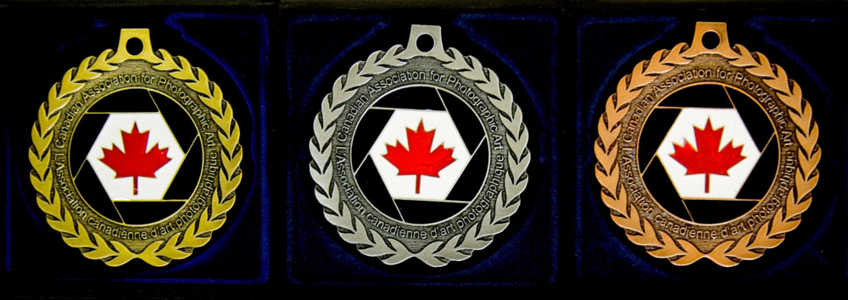
Current bilingual CAPA medals

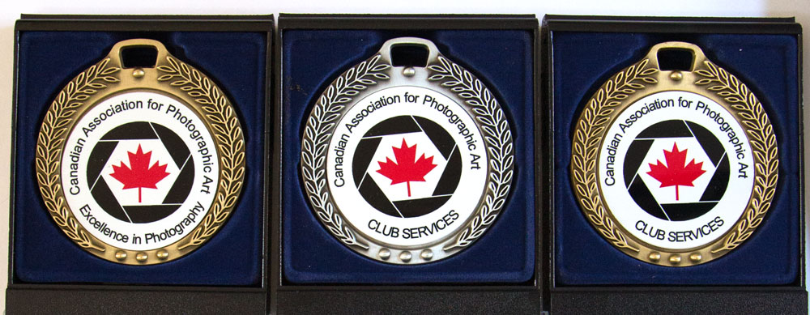
CAPA’s Excellence in Photography (English) – would be similar for the Club Service Medal in the language of choice (English or French)

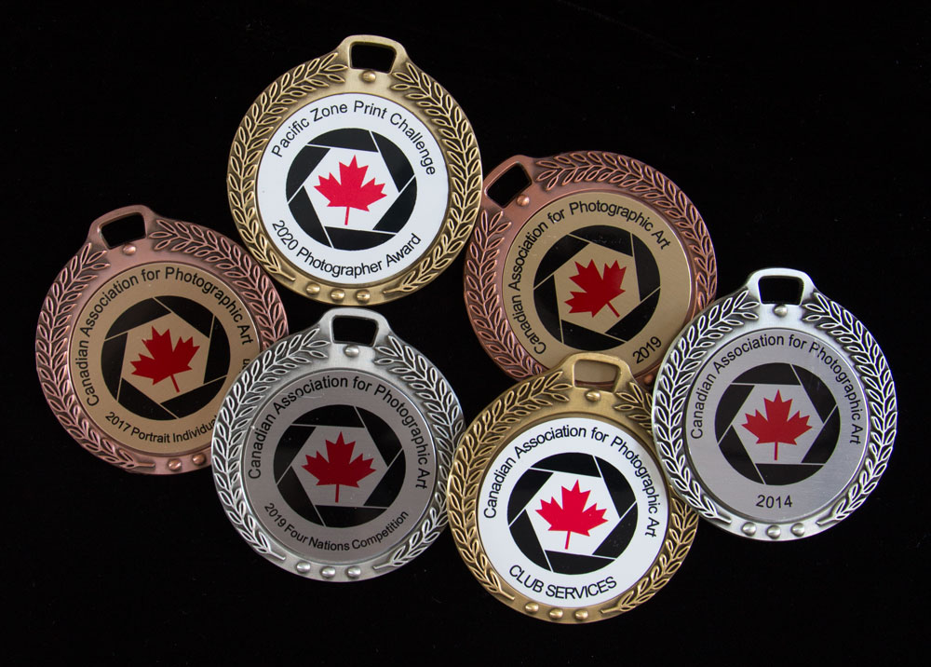
Sample of some custom ordered medals.

